[Perspective/Feature Article/Review] | doi: 10.3866/PKU.WHXB20xxxxxxx | www.whxb.pku.edu.cn
Title
Author A ¹, Author B ², Author C ², Author D ^{1,*}
¹ affiliation.
² affiliation.
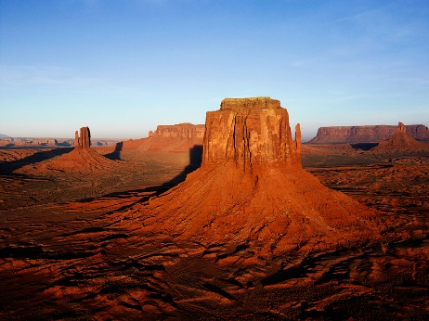
Abstract: A single paragraph of about 400 words. For research articles, abstracts should give a pertinent overview of the work. We strongly encourage authors to use the following style of structured abstracts, but without headings: (1) Background: Place the question addressed in a broad context and highlight the purpose of the study; (2) Methods: Describe briefly the main methods or treatments applied; (3) Results: Summarize the article's main findings; and (4) Conclusions: Indicate the main conclusions or interpretations. The abstract should be an objective representation of the article, it must not contain results which are not presented and substantiated in the main text and should not exaggerate the main conclusions.
Key Words: Keyword 1; Keyword 2; Keyword 3; Keyword 4; Keyword 5

1 Introduction
The introduction should briefly place the study in a broad context and highlight why it is important. It should define the purpose of the work and its significance. The current state of the research field should be reviewed carefully and key publications cited. Please highlight controversial and diverging hypotheses when necessary. Finally, briefly mention the main aim of the work and highlight the principal conclusions. As far as possible, please keep the introduction comprehensible to scientists outside your particular field of research. References should be numbered in order of appearance and indicated by a numeral or numerals in square brackets ¹. See the end of the document for further details on references ².
2 Section
2.1 Subsection
The text continues here.
3 Section
The text continues here.
3.1 Subsection
3.1.1 Subsubsection
Column chart (Fig. 1).
3.2 Subsection
Columns of the table (Table 1), Banner figure (Fig. 2).

Fig. 1 Caption
Table 1 Caption
Heading 1 | Heading 2
entry 1 | data
entry 2 | data
entry 3 | data
entry 4 | data
entry 5 | data
entry 6 | data
Table may have a footer.
4 Conclusions
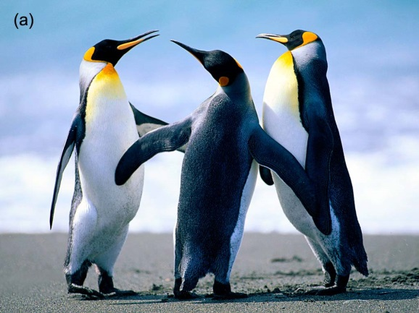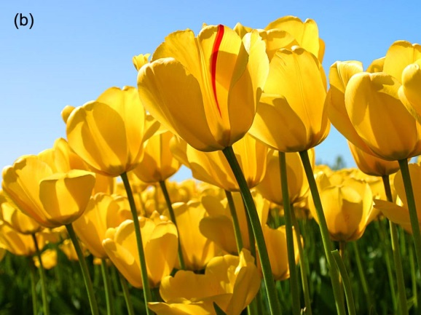
Fig. 2 This is a figure, Schemes follow the same formatting.
If there are multiple panels, they should be listed as: (a) Description of what is contained in the first panel; (b) Description of what is contained in the second panel.
Figures should be placed in the main text near to the first time they are cited. A caption on a single line should be centered.
This section may be divided by subheadings. It should provide a concise and precise description of the experimental results, their interpretation as well as the experimental conclusions that can be drawn.
Acknowledgment: The text continues here.
Author Contribution: For research articles with several authors, a short paragraph specifying their individual contributions must be provided. The following statements should be used “Conceptualization, X.X. and Y.Y.; Methodology, X.X.; Software, X.X.; Validation, X.X., Y.Y. and Z.Z.; Formal Analysis, X.X.; Investigation, X.X.; Resources, X.X.; Data Curation, X.X.; Writing – Original Draft Preparation, X.X.; Writing – Review & Editing, X.X.; Visualization, X.X.; Supervision, X.X.; Project Administration, X.X.; Funding Acquisition, Y.Y.”
Supporting Information: available free of charge via the internet at http://www.whxb.pku.edu.cn.
References
- Author 1, A. B.; Author 2, C. D. Abbreviated Journal Name Year, Volume, page. doi:
- Author 1, A. B.; Author 2, C. D. Abbreviated Journal Name Year, Volume, page. doi:
- Author 1, A. B.; Author 2, C. D. Book Title, 2nd ed.; Publisher: Location, Country, year; pp. xx−xx.
- Author 1, A. B.; Author 2, C. D. Title of the chapter. In Book Title; Editor1, A. B., Editor2, C. Eds.; Publisher: Publisher Location, Country, year; pp. xxx−xxx.
- Author 1, A. B. Book Titles; Publisher: Location of publisher, Country, Year; pp xxx−xxx; translated by Translator 1, A. B., Translator 2, C. D., Translator 3, E. F.
- Author 1, A. B.; Author 2, C. D. Title of Patent. Patent Number, Year-Month-Day.
- Author 1, A. B.; Author 2, C. D. Title of Patent. E Patent Number, Year.
- Author. Title of Thesis. Level of Dissertation, University, Location of University, Year.
- URL (accessed Dar Month Year).
- Author 1, A. B.; Author 2, C. D. Program Title, version or edition; Publisher: Place of Publication, Year
TOC
Please according to the theme of this article: (1) to design 1 exquisite color map (Must not be published), picture is concise and lively, with eye-catching effect. (2) The most representative of the essence of content of 1–2 sentences (not more than 20 words).

